

GospelPreaching.com
Analysis Report

Table of Contents
System Requirements 5
Brief Overview 5
Event Table 6
Use Case Diagrams 7
Administrator Use Cases 7
Visitor Use Cases 8
Domain Model Class Diagram 9
Use Case Descriptions 10
Fully Described Use Cases 10
Add Article 10
Update Article 11
View Article 12
Add Author 12
Create Category 13
Register User 13
Approve New User 14
Update User Profile 14
Add Comment 15
Remove Comment 15
Like An Article 16
Unlike An Article 16
Ask Question 17
Update Question 18
Add Product 19
Create New Order 20
Record Order As Shipped 21
Adjust Order 22
Brief Use Case Descriptions 23
Delete Article 23
View Author 23
Update Author 23
Delete Author 23
View Category 23
Update Category 23
Delete Category 23
View Tagged Articles 23
View User Profile 23
Delete User 23
View Question 24
View Product 24
Update Product 24
Delete Product 24
View Recent Orders 24
System Sequence Diagrams 25
Add Article 25
Update Article 26
View Article 27
Add Author 27
Create Category 27
Register User 28
Approve New User 28
Update User Profile 28
Add Comment 29
Remove Comment 29
Like An Article 29
Unlike An Article 30
Ask Question 30
Update Question 30
Add Product 31
Create New Order 32
Record Order As Shipped 33
Adjust Order 33
Attribute Definitions 34
Article 34
Audio 34
Video 34
Document 34
OtherMedia 34
Category 35
Tag 35
Author 35
UserProfile 35
Comment 35
Like 35
Question 36
Product 36
OrderItem 36
Order 37
Alternate Design Concepts and Recommendation 38
Varying the scope of the system 38
Varying the degree of automation 38
Varying the type of technology used 38
Varying the approach to implementation 38
Project Alternatives 38
Recommended Alternative 39
Design and Implementation to Date 39
Technology and Working Environment 39
View Article Extended Sequence Diagram 40
Implementation to Date 41
Use Cases Implemented 41
Example Implementation 41
Initial Menu Hierarchy 45
Report Samples 47
Article Report by Category 47
Article Report by Author 47
Project Monitoring/Reporting To Date 48
Appendix A: Code Excerpts 51
models.py 51
views.py 53
urls.py 53
admin.py 54
index.html 55
detail.html 56
Legal Notes 58
Other Notes 58

System Requirements

Brief Overview
CFTF Publications is a small publisher of religious books, tracts, and other media related to the Church of Christ. Allen Bailey is the owner/operator. Writers or extra editors are hired or volunteer on an as-needed basis. The company's main goal is to spread the Gospel and edify existing Christians through the publishing/availability of religious materials. CFTF doesn't have any physical publishing facilities.

The system is going to be an online portal for CFTF's electronic resources (documents, audio, video, etc.) and a storefront for the company's published goods. The system will simply be known as “GospelPreaching.com”. Along with the system's basic functions mentioned above, it will also provide the ability to categorize and tag electronic materials, post and respond to questions (Q&A), allow users to connect their profiles with social networking sites (Facebook, Twitter, etc.), post comments, and “like” (favorite) articles.

Allen Bailey would be the principle user of the site, performing administrative functions in the system. Other users would include the site visitors would be viewing the electronic resources, purchasing published goods, and utilizing the social aspects of the site. There is also the possibility of hiring or finding volunteers to perform the conversion of materials to electronic format. These people would need to have the ability to upload new materials to the site.

Event Table

Use Case Diagrams

Administrator Use Cases
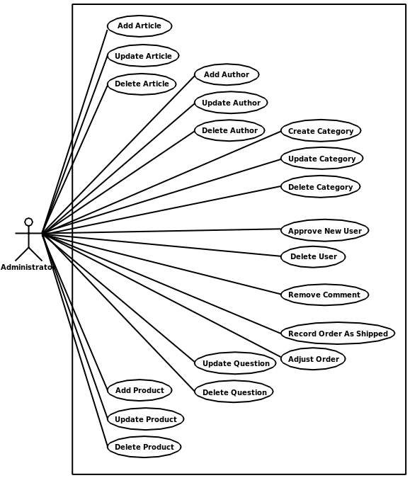

Visitor Use Cases
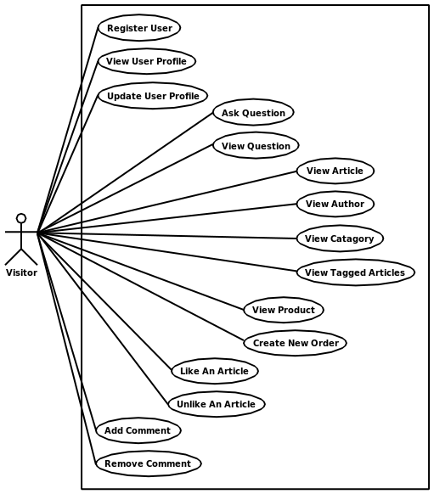

Domain Model Class Diagram
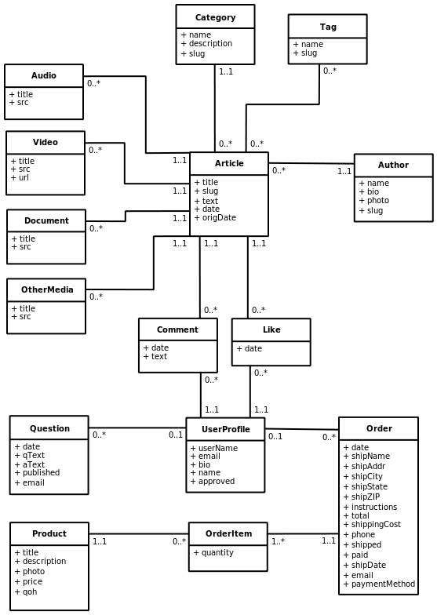

Use Case Descriptions

Fully Described Use Cases
Use Case Name: | Add Article
Scenario: | Add article
Triggering Event: | Administrator enters new Article details.
Brief Description: | Administrator logs on and navigates to the Add Article page. Administrator fills in Article details; selects a Category, Author, and Tags; attaches new media items; and submits finished Article.
Actors: | Administrator
Stakeholders:
Preconditions: | Category and Author must exist.
Postconditions: | Article and media items (Audio, Video, Document, OtherMedia) must be created.  Media items must be associated with Article.  Article must be associated with Category and Author.
Flow of Activities: | Actor | System
Flow of Activities: | - Administrator connects to the site and navigates to the administration page.  - Administrator logs in.  - Administrator navigates to the Add Article page.  - Administrator fills in Article details.  - Administrator selects Category.  - Administrator selects Author.  - Administrator selects Tags.  - Administrator requests to add a new media item (Audio, Video, Document, or OtherMedia).  - Administrator fills in new media item details.  - Repeat steps 8 and 9.  - Administrator submits completed Article. | 2.1 Validate administrator account.  3.1 Display new Article form.  8.1 Add a new form to the page for the new media item.  11.1 Add Article confirmation and return to administration page.
Exception Conditions: | 5.1 If Category does not exist yet, user can click link to open new window and add a new Category.  5.1 If Author does not exist yet, user can click link to open new window and add a new Author.  5.1 If a Tag does not exist yet, user can click link to open new window and add a new Tag.

Use Case Name: | Update Article
Scenario: | Update article
Triggering Event: | Administrator updates Article details.
Brief Description: | Administrator logs on and navigates to the Article update page. Administrator updates Article details and submits finished Article.
Actors: | Administrator
Stakeholders:
Preconditions: | Category and Author must exist.
Postconditions: | Article and media items (Audio, Video, Document, OtherMedia) must be updated.  Media items must be associated with Article.  Article associations with Category and Author must be updated.
Flow of Activities: | Actor | System
Flow of Activities: | - Administrator connects to the site and navigates to the administration page.  - Administrator logs in.  - Administrator finds the Article to update and selects the Update option.  - Administrator updates Article details.  - Administrator updates Category.  - Administrator updates Author.  - Administrator updates Tags.  - Administrator requests to add a new media item (Audio, Video, Document, or OtherMedia).  - Administrator fills in new media item details.  - Repeat steps 8 and 9.  - Administrator marks media item for deletion.  - Administrator updates existing media item details.  - Administrator submits updated Article. | 2.1 Validate administrator account.  3.1 Display Article update form.  8.1 Add a new form to the page for the new media item.  13.1 Update Article confirmation and return to administration page.
Exception Conditions: | 5.1 If Category does not exist yet, user can click link to open new window and add a new Category.  5.1 If Author does not exist yet, user can click link to open new window and add a new Author.  5.1 If a Tag does not exist yet, user can click link to open new window and add a new Tag.

Use Case Name: | View Article
Scenario: | View Article
Triggering Event: | Visitor requests to view an Article
Brief Description: | Visitor locates an Article and requests to view the Article details.
Actors: | Visitor
Stakeholders:
Preconditions: | Article must exist.
Postconditions:
Flow of Activities: | Actor | System
Flow of Activities: | - Visitor connects to site and navigates to the main Article list.  1a. Visitor navigates to Category, Author, or Tag view.  - Visitor selects Article from list to view details.  2a. Visitor enters Article URL directly. | 1.1 Display list of all Articles.  1a.1 Display list of Articles by Category, Author, or Tag.  2.1 Display Article details and media item (Audio, Video, Document, OtherMedia) details/players.
Exception Conditions: | 2.1 If Article does not exist, redirect Visitor to error page.

Use Case Name: | Add Author
Scenario: | Add Author
Triggering Event: | Administrator enters new Author details.
Brief Description: | Administrator logs on and navigates to the Add Author page. Administrator fills in Author details and submits finished Author details.
Actors: | Administrator
Stakeholders:
Preconditions:
Postconditions: | Author must created.
Flow of Activities: | Actor | System
Flow of Activities: | - Administrator connects to the site and navigates to the administration page.  - Administrator logs in.  - Administrator navigates to the Add Author page.  - Administrator fills in Author details.  - Administrator submits completed Author details. | 2.1 Validate administrator account.  3.1 Display new Author form.  5.1 Add Author confirmation and return to administration page.
Exception Conditions:
Use Case Name: | Create Category
Scenario: | Create Category
Triggering Event: | Administrator enters new Category details.
Brief Description: | Administrator logs on and navigates to the Add Category page. Administrator fills in Author details and submits finished Category details.
Actors: | Administrator
Stakeholders:
Preconditions:
Postconditions: | Category must created.
Flow of Activities: | Actor | System
Flow of Activities: | - Administrator connects to the site and navigates to the administration page.  - Administrator logs in.  - Administrator navigates to the Add Category page.  - Administrator fills in Category details.  - Administrator submits completed Category details. | 2.1 Validate administrator account.  3.1 Display new Category form.  5.1 Add Category confirmation and return to administration page.
Exception Conditions:

Use Case Name: | Register User
Scenario: | Register User
Triggering Event: | Visitor requests to register a new account.
Brief Description: | Visitor requests to register a new account and provides profile information.
Actors: | Visitor
Stakeholders: | Administrator: to respond to registration request.
Preconditions:
Postconditions: | Unapproved User Profile created.
Flow of Activities: | Actor | System
Flow of Activities: | - Visitor connects to site and clicks the register link.  - Visitor submits registration form with profile information. | 1.1 Display User registration form.  2.1 Confirm successful registration.  2.2 Notify Administrator of new user account.
Exception Conditions:

Use Case Name: | Approve New User
Scenario: | Approve New User
Triggering Event: | Administrator requests user approval.
Brief Description: | Administrator logs onto site and approves user.
Actors: | Administrator
Stakeholders: | Visitor: account approval notice.
Preconditions: | Unapproved User Profile must exist.
Postconditions: | User Profile updated with approved status.
Flow of Activities: | Actor | System
Flow of Activities: | - Administrator connects to site and navigates to the administration page.  - Administrator logs in.  - Administrator navigates to the user approval page.  - Administrator requests approval of User Profile. | 2.1 Validate administrator account.  4.1 User approval confirmation and return to administration page.
Exception Conditions: | 4.1 If Administrator decides to not approve user profile, it can be deleted instead.

Use Case Name: | Update User Profile
Scenario: | Update User Profile
Triggering Event: | Visitor updates User Profile details.
Brief Description: | Visitor logs on and navigates to the User Profile update page. Visitor updates User Profile details and submits finished details.
Actors: | Visitor
Stakeholders:
Preconditions: | User Profile must exist.
Postconditions: | User Profile must be updated.
Flow of Activities: | Actor | System
Flow of Activities: | - Visitor connects to site and logs in.  - Visitor navigates to the profile update page.  - Visitor updates User Profile details.  - Visitor submits updated User Profile. | 1.1 Validate user account.  2.1 Display User Profile update form.  4.1 User Profile update confirmation and return to User Profile page.
Exception Conditions:

Use Case Name: | Add Comment
Scenario: | Add Comment
Triggering Event: | Visitor creates new Comment.
Brief Description: | Visitor logs onto site and navigates to an Article. Visitor submits Comment text using new Comment form.
Actors: | Visitor
Stakeholders:
Preconditions: | Article must exist.
Postconditions: | Comment must be created and associated to Article.
Flow of Activities: | Actor | System
Flow of Activities: | - Visitor connects to site and logs in.  - Visitor navigates to an Article.  - Visitor submits new Comment details. | 1.1 Validate user account.  2.1 Display Article details and new Comment form.  3.1 Add Comment confirmation.
Exception Conditions:

Use Case Name: | Remove Comment
Scenario: | Remove Comment
Triggering Event: | Visitor or Administrator requests removal of Comment.
Brief Description: | Visitor or Administrator logs onto site and navigates to an Article. Visitor or Administrator removes a Comment from the Article.
Actors: | Visitor, Administrator
Stakeholders:
Preconditions: | Comment must exist.
Postconditions: | Comment must be removed.
Flow of Activities: | Actor | System
Flow of Activities: | - Visitor or Administrator connects to site and logs in.  - Visitor or Administrator navigates to an Article.  - Visitor or Administrator requests removal of Comment. | 1.1 Validate account.  2.1 Display Article details including existing comments.  3.1a If Visitor: validate ownership of comment and confirm removal.  3.1b If Administrator: confirm removal.
Exception Conditions:

Use Case Name: | Like An Article
Scenario: | Like An Article
Triggering Event: | Visitor submits Like request.
Brief Description: | Visitor logs onto site and navigates to an Article. Visitor requests a Like for the Article.
Actors: | Visitor
Stakeholders:
Preconditions: | Article and User Profile must exist.
Postconditions: | Like must be created and associated with Article and User Profile.
Flow of Activities: | Actor | System
Flow of Activities: | - Visitor connects to site and logs in.  - Visitor navigates to an Article.  - Visitor requests a new Like | 1.1 Validate user account.  2.1 Display Article details  3.1 New Like confirmation.
Exception Conditions:

Use Case Name: | Unlike An Article
Scenario: | Unlike An Article
Triggering Event: | Visitor submits Unlike request.
Brief Description: | Visitor logs onto site and navigates to an Article. Visitor requests Like for the Article be removed.
Actors: | Visitor
Stakeholders:
Preconditions: | Article, User Profile, and Like must exist.
Postconditions: | Like must be removed.
Flow of Activities: | Actor | System
Flow of Activities: | - Visitor connects to site and logs in.  - Visitor navigates to an Article.  - Visitor requests removal of Like for this Article. | 1.1 Validate user account.  2.1 Display Article details  3.1 Like removal confirmation.
Exception Conditions:

Use Case Name: | Ask Question
Scenario: | Ask Question
Triggering Event: | Visitor submits new Question details.
Brief Description: | Visitor submits a new Question and Administrator is alerted.
Actors: | Visitor
Stakeholders: | Administrator: alert to respond to question.
Preconditions:
Postconditions: | Question is created and either has an email address or is associated with a User Profile
Flow of Activities: | Actor | System
Flow of Activities: | - Visitor connects to site and logs in.  - Visitor navigates to the Ask Question page.  - Visitor submits complete new Question details. | 1.1 Validate user account.  2.1 Display Ask Question form.  3.1 Question submission confirmation and return to main question page.
Exception Conditions: | 3.1 If Visitor did not log in under step 1, require email address field.

Use Case Name: | Update Question
Scenario: | Update Question
Triggering Event: | Administrator updates Question details.
Brief Description: | Administrator logs on and navigates to the Question update page. Administrator updates Question details and submits finished Question.
Actors: | Administrator
Stakeholders: | Visitor: alert that question has been answered.
Preconditions: | Question must exist.
Postconditions: | Question must be updated.
Flow of Activities: | Actor | System
Flow of Activities: | - Administrator connects to the site and navigates to the administration page.  - Administrator logs in.  - Administrator finds the Question to update and selects the Update option.  - Administrator updates Question details.  - Administrator submits updated Question. | 2.1 Validate administrator account.  3.1 Display Question update form.  5.1 Update Question confirmation and return to administration page.  5.2 Send notice of answered/updated question to Visitor if published.
Exception Conditions:

Use Case Name: | Add Product
Scenario: | Add Product
Triggering Event: | Administrator enters new Product details.
Brief Description: | Administrator logs on and navigates to the Add Product page. Administrator fills in Product details and submits finished Product.
Actors: | Administrator
Stakeholders:
Preconditions:
Postconditions: | Product must be created.
Flow of Activities: | Actor | System
Flow of Activities: | - Administrator connects to the site and navigates to the administration page.  - Administrator logs in.  - Administrator navigates to the Add Product page.  - Administrator fills in Product details.  - Administrator submits completed Product. | 2.1 Validate administrator account.  3.1 Display new Product form.  5.1 Add Product confirmation and return to administration page.
Exception Conditions:

Use Case Name: | Create New Order
Scenario: | Create New Order
Triggering Event: | Visitor enters new Order details.
Brief Description: | Visitor connects to site. Visitor selects desired products and fills in Order details. Visitor is taken to payment screen if needed and fills it out. Visitor submits finished Order.
Actors: | Visitor
Stakeholders: | Administrator: process new order.  Paypal: payment details.
Preconditions: | Products must exist.
Postconditions: | Order and Order Items must exist.  Order Items must be associated with Order.  User Profile, if logged in, must be associated with Order.  Product QOH must be updated.
Flow of Activities: | Actor | System
Flow of Activities: | - Visitor navigates to the Product page.  - Visitor requests Product details.  - Visitor requests Product be added to Order.  - Repeat steps 1-3.  - Visitor clicks the checkout link to finish placing Order.  - Visitor submits Order details.  - Visitor completes payment information on Paypal site. | 2.1 Display product details.  3.1 Product added to cart.  5.1 Display checkout form.  6.1a If Visitor indicates payment by check: inform them about check policy and submit for manual processing by Administrator.  6.1b If Visitor indicates Paypal payment: redirect to Paypal payment screen/site.  7.1 Paypal confirms payment receipt.  7.2 Paypal sends IPN message to listener and payment details are processed and saved.  7.3 If Paypal payment is successful: Order is marked paid and Administrator is notified.
Exception Conditions: | 7.1 If Paypal payment is not successful: Order is left marked unpaid and Administrator is notified for manual processing.

Use Case Name: | Record Order As Shipped
Scenario: | Record Order As Shipped
Triggering Event: | Administrator requests to mark Order as shipped.
Brief Description: | Administrator logs onto site and marks Order as shipped.
Actors: | Administrator
Stakeholders: | Visitor: alert that order has shipped.
Preconditions: | Order must exist.
Postconditions: | Order must be updated with shipped status.
Flow of Activities: | Actor | System
Flow of Activities: | - Administrator connects to site and navigates to the administration page.  - Administrator logs in.  - Administrator navigates to the unshipped Order page.  - Administrator requests to mark Order as shipped | 2.1 Validate administrator account.  4.1 Order shipped confirmation and return to administration page.  4.2 Send notification of Order shipment to Visitor.
Exception Conditions:

Use Case Name: | Adjust Order
Scenario: | Adjust Order
Triggering Event: | Administrator updates Order details.
Brief Description: | Administrator logs on and navigates to the Order adjustment page. Administrator adjusts Order details and submits adjusted Order.
Actors: | Administrator
Stakeholders:
Preconditions: | Order must exist.
Postconditions: | Order must be updated.
Flow of Activities: | Actor | System
Flow of Activities: | - Administrator connects to the site and navigates to the administration page.  - Administrator logs in.  - Administrator finds the Order to update and selects the Update option.  - Administrator updates Order details.  - Administrator submits adjusted Order.  - Administrator manually adjusts payment and notifies visitor of any changes. | 2.1 Validate administrator account.  3.1 Display Order update form.  5.1 Order adjustment confirmation and return to administration page.
Exception Conditions:

Brief Use Case Descriptions

Delete Article
Administrator logs onto site and navigates to the Article page. Administrator requests to delete Article.

View Author
Visitor navigates to the Author page and requests to view Author details. System displays report of associated Articles and Author details.

Update Author
Administrator logs onto site and navigates to the Author update page. Administrator submits updated Author details.

Delete Author
Administrator logs onto site and navigates to the Author page. Administrator requests to delete Author.

View Category
Visitor navigates to the Category page and requests to view Category details. System displays report of associated Articles and Category details

Update Category
Administrator logs onto site and navigates to the Category update page. Administrator submits updated Category details.

Delete Category
Administrator logs onto site and navigates to the Category page. Administrator requests to delete Category.

View Tagged Articles
Visitor navigates to the Tag page and requests to view tagged Articles. System displays Articles associated with that Tag.

View User Profile
Visitor navigates to User page and requests to view User Profile details. System displays User Profile details.

Delete User
Administrator or Visitor logs onto site and navigates to the User Profile detail page. Administrator or Visitor requests to delete User.

View Question
Visitor navigates to Question page and requests to view Question details. System displays Question details.

View Product
Visitor navigates to Product page and requests to view Product details. System displays Product details.

Update Product
Administrator logs onto site and navigates to the Product update page. Administrator submits updated Product details.

Delete Product
Administrator logs onto site and navigates to the Product page. Administrator requests to delete Product.

View Recent Orders
Administrator logs onto site and requests a report of all recent orders by date. System displays report.

System Sequence Diagrams

Add Article
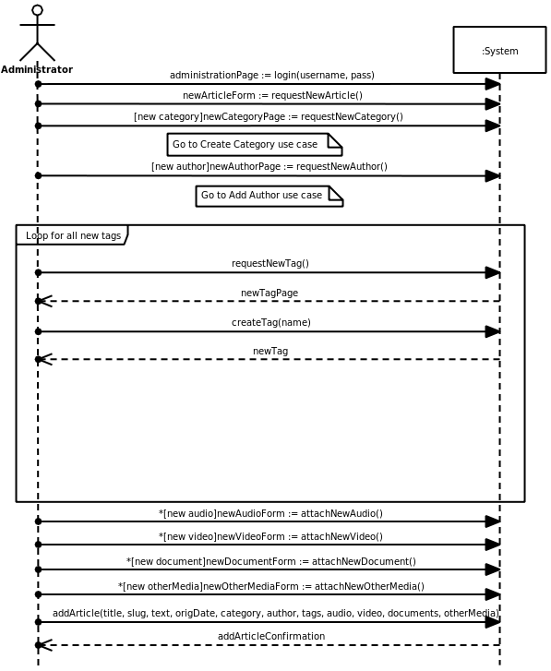

Update Article
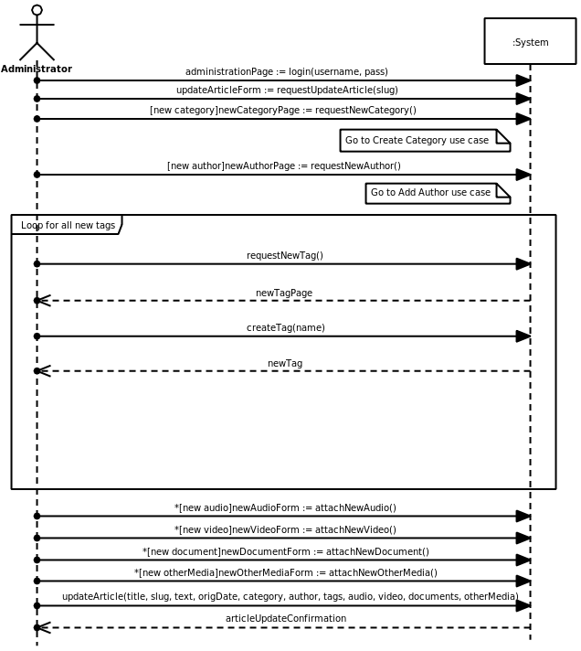

View Article
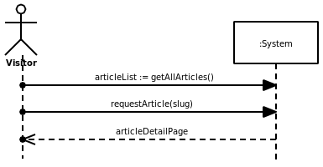

Add Author
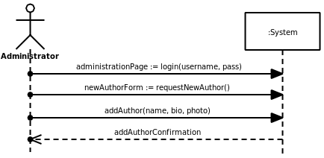

Create Category
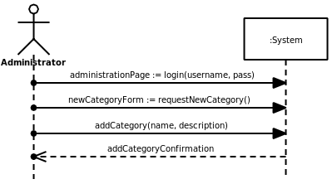

Register User
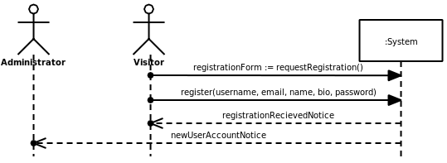

Approve New User
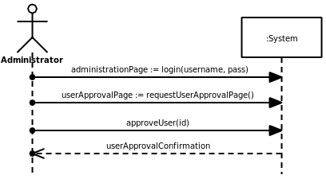

Update User Profile
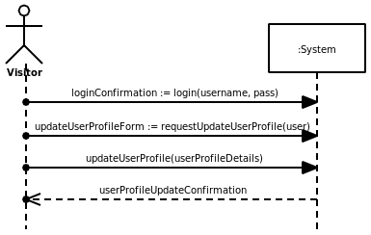

Add Comment
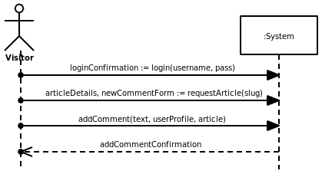

Remove Comment
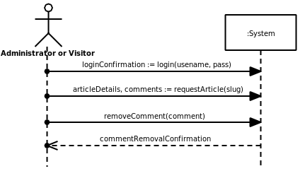

Like An Article
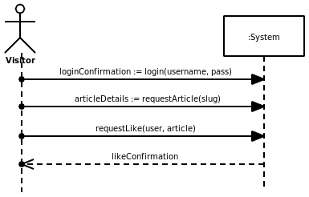

Unlike An Article
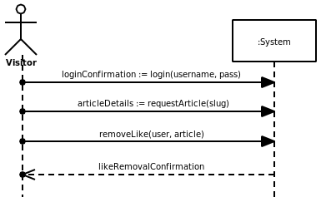

Ask Question
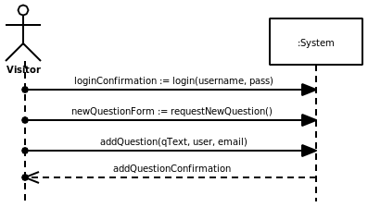

Update Question
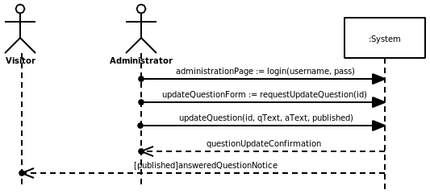

Add Product
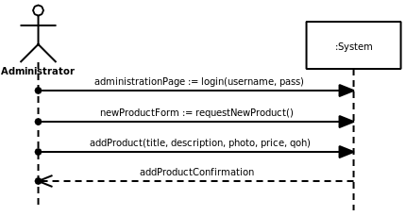

Create New Order
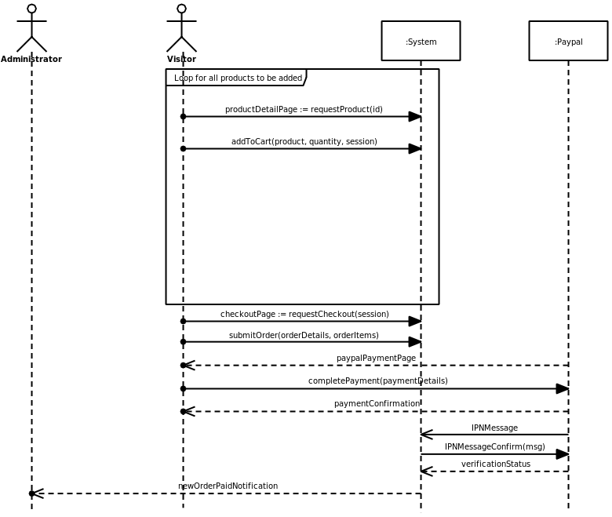

Record Order As Shipped
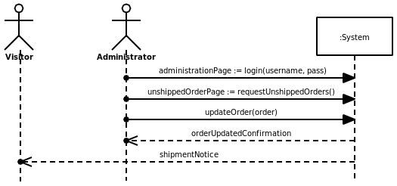

Adjust Order
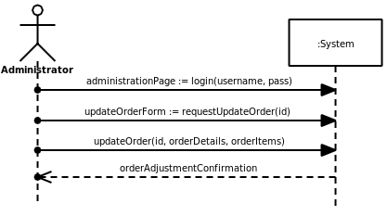

Attribute Definitions

Article
Attribute | Meaning | Data Type | Rules
Title | The title of the article. | String | Required
Slug | A URL-friendly identifier for the article, based on the title. | String | Required
Text | Rich text content. | String | Optional
Date | Date the article was published on the site. | DateTime | Required, Timestamp
OrigDate | Date of the article's original publication. | Date | Required

Audio
Attribute | Meaning | Data Type | Rules
Title | The title of the audio file. | String | Required
Src | Path to the file on the server. | String | Required

Video
Attribute | Meaning | Data Type | Rules
Title | The title of the video file. | String | Required
Src | Path to the file on the server. | String | Either scr or url must be selected.
Url | URL to a YouTube video. | String | Either scr or url must be selected.

Document
Attribute | Meaning | Data Type | Rules
Title | The title of the document. | String | Required
Src | Path to the file on the server. | String | Required

OtherMedia
Attribute | Meaning | Data Type | Rules
Title | The title of the media file. | String | Required
Src | Path to the file on the server. | String | Required

Category
Attribute | Meaning | Data Type | Rules
Name | Category name or title. | String | Required
Description | Rich text description of category. | String | Optional
Slug | A URL-friendly identifier for the category, based on the name. | String | Required

Tag
Attribute | Meaning | Data Type | Rules
Name | Tag name/title. | String | Required
Slug | A URL-friendly identifier for the tag, based on the name. | String | Required

Author
Attribute | Meaning | Data Type | Rules
Name | Author's actual name. | String | Required
Bio | Brief biography in rich text. | String | Optional
Photo | Path to a photo of the author. | String | Optional
Slug | A URL-friendly identifier for the author, based on the name. | String | Required

UserProfile
Attribute | Meaning | Data Type | Rules
UserName | Username for the profile. | String | Required
Email | User's email address. | String | Required
Bio | A brief, rich text, “About Me” section. | String | Optional
Name | User's real name. | String | Required
Approved | Flag to indicate if the user is approved to post comments. | Bool | Required

Comment
Attribute | Meaning | Data Type | Rules
Date | Date the comment was posted. | DateTime | Required, Timestamp
Text | Plain text body of the comment. | String | Required

Like
Attribute | Meaning | Data Type | Rules
Date | Date the article was liked. | DateTime | Required, Timestamp

Question
Attribute | Meaning | Data Type | Rules
Date | Date the question was entered. | DateTime | Required
qText | Plain text question body. | String | Required
aText | Rich text answer body. | String | Optional until published.
published | Flag to mark Question as published, otherwise draft. | Bool | Required
email | Email address if the visitor was not a registered user. | String | Required if not associated with a UserProfile object.

Product
Attribute | Meaning | Data Type | Rules
Title | Name of product. | String | Required
Description | Rich text description of product. | String | Required
Photo | Path to photo of product. | String | Optional
Price | Product price. | Double | Required
QOH | Quantity on hand, for tracking inventory. | Int | Required

OrderItem
Attribute | Meaning | Data Type | Rules
Quantity | Quantity of product ordered. | Int | Required

Order
Attribute | Meaning | Data Type | Rules
Date | Date order was placed. | DateTime | Required, Timestamp
Email | Contact e-mail address for visitors not logged in. | String | Optional, Required if not associated with a user.
Phone | Contact phone number. | String | Required
ShipName | Shipping Name if not using Paypal. | String | Optional
ShipAddr | Shipping Address if not using Paypal. | String | Optional
ShipCity | Shipping City if not using Paypal. | String | Optional
ShipState | Shipping State if not using Paypal. | String | Optional
ShipZIP | Shipping ZIP code if not using Paypal. | String | Optional
Instructions | Special instructions in plain text. | String | Optional
ShippingCost | Calculated shipping cost. | Double | Required, Calculated
Total | Calculated order total. | Double | Required, Calculated
Paid | Flag to indicate if order has been paid. | Bool | Required
Shipped | Flag to indicate if order has been shipped | Bool | Required
ShipDate | Date order was shipped. | DateTime | Optional, Timestamp
PaymentMethod | Indicates what payment method was used. Currently 2 options: “Check” or “Paypal”. | String | Required, “Check” or “Paypal”

Alternate Design Concepts and Recommendation

Varying the scope of the system
The scope of this system could be varied considerably. The business owner has many more modules and features he would like added on in the future. As a result, the scope could be expanded almost indefinitely. The scope could also be reduced since the e-commerce functionality is not something the client had listed as a priority.

Varying the degree of automation
The degree of automation could be changed by adding a desktop application that would help handle the conversion of various analog multimedia sources and automatically post the results to the site. The e-commerce section could become more automated by eliminating the manual processing of checks and automatically printing packing slips and printing labels. It could also be changed to require manual handling of all orders.

Varying the type of technology used
The application is currently using Django, but it could be changed to use Ruby on Rails, PHP, or ASP.NET. The application is web-based by nature, so converting it to a desktop application would not make much sense.

Varying the approach to implementation
The application could be developed as an add-on to an existing CMS platform such as Wordpress instead of creating a custom system.

Project Alternatives
- Add religious discussion board and Gospel music internet radio to the scope.
- Take e-commerce section out of scope.
- Include desktop media conversion application.
- Develop using Ruby on Rails

Recommended Alternative
I've chosen to go with this particular project scope because I feel the e-commerce section would be highly beneficial to the business and would help contribute a lot of NPV to the project. I also think that a religious discussion board and Gospel music internet radio app would expand the scope beyond what could be managed efficiently in this iteration without contributing very much of a benefit to the site's users. The desktop media conversion application would stretch the scope to much as well, with little improvement in function. I decided to go with Django instead of Ruby on Rails because I feel Django has a much richer set of platform features and I am more familiar with its use.

Design and Implementation to Date

Technology and Working Environment
The application architecture I am using is a modified version of the MVC approach to web development unique to the Django platform.
The models, or data access takes place in models.py. No SQL strings are ever directly manipulated by user created code; the Django framework handles all of that. The structure of the classes is simply defined in the model and all the SQL string conversion are taken care of automatically based on the connection settings in the main settings.py file.
The controller code is mostly handled by the framework. However, there are configuration settings that manage the functionality of the controller layer. The most notable of these is the urls.py file which defines which view to display.
According to the Django's interpretation of MVC, the views.py file manages the view layer. This interpretation defines the view layer as making the decision of what to display, instead of how to display it. This logic would traditionally be found in the controller layer in other MVC frameworks, which is one area where Django differs.
The final piece of the puzzle is the template system. The templates define how the information is to be displayed, and consist of HTML files with template tags. However, Django does not consider these to be part of any of the three layers.
The code for the system will strongly object-oriented and dynamic thanks to the Python language.
I've provided a sequence diagram for the View Article use case to illustrate this structure as well as possible.
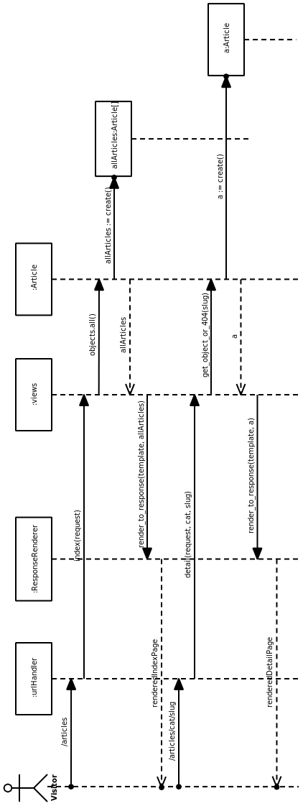

View Article Extended Sequence Diagram

Implementation to Date

Use Cases Implemented
- Add Article
- View Article
- Update Article
- Delete Article
- Add Author
- Update Author
- Delete Author
- Create Category
- View Category
- Update Category
- Delete Category

Example Implementation
View Article Use Case
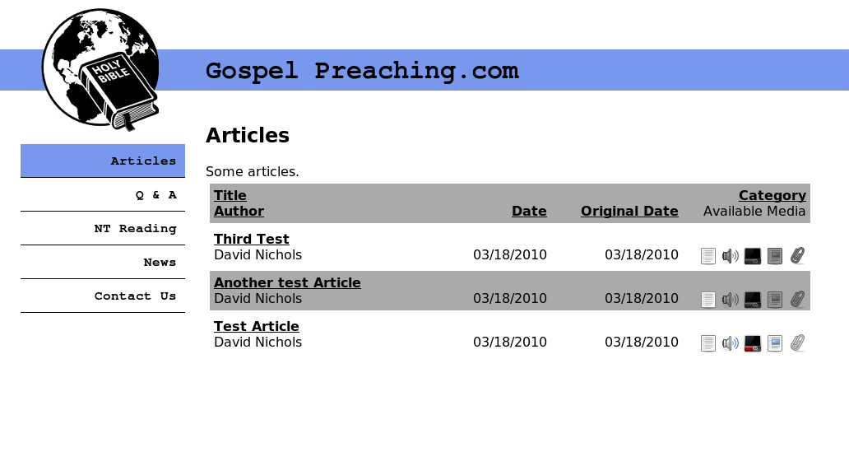Article Index Page
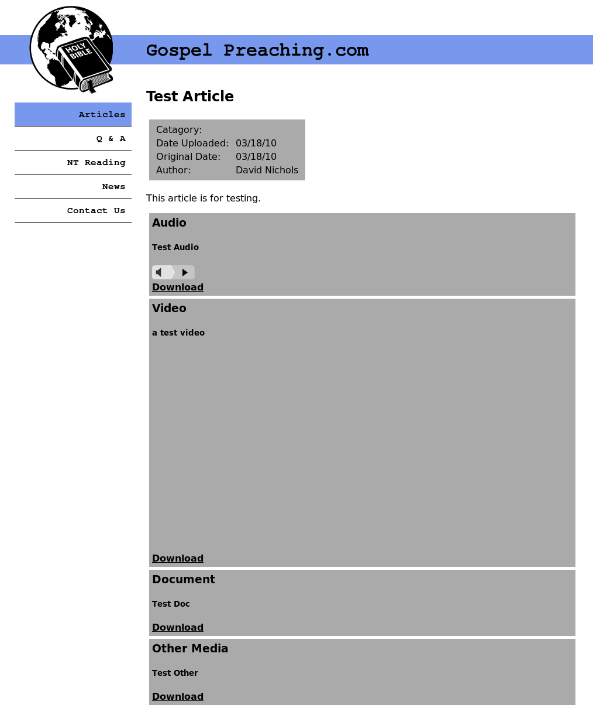Article Detail Page
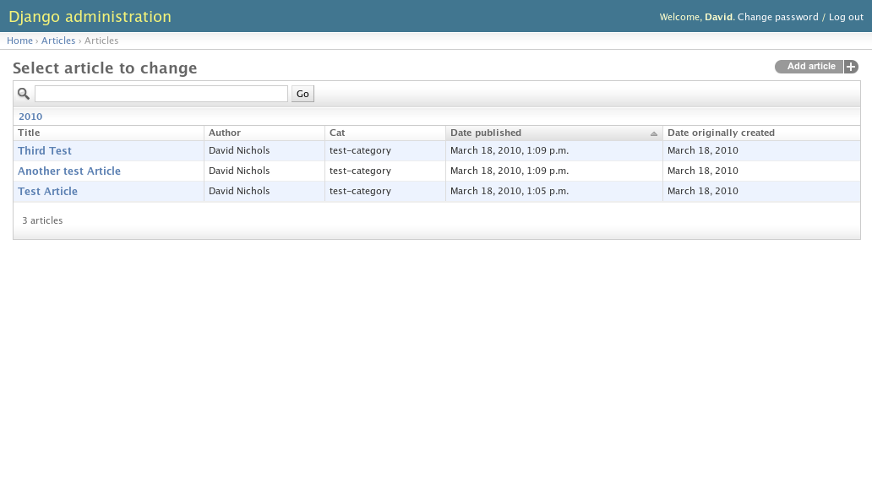Administration Page Article List
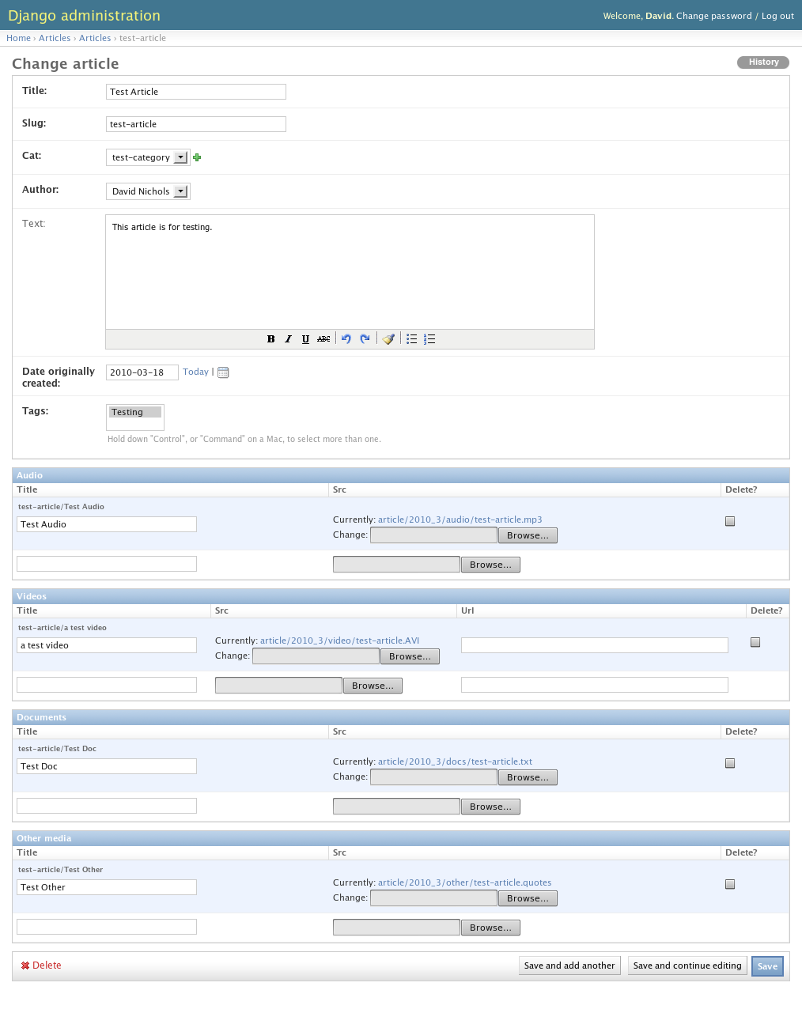Administration Update/View Article
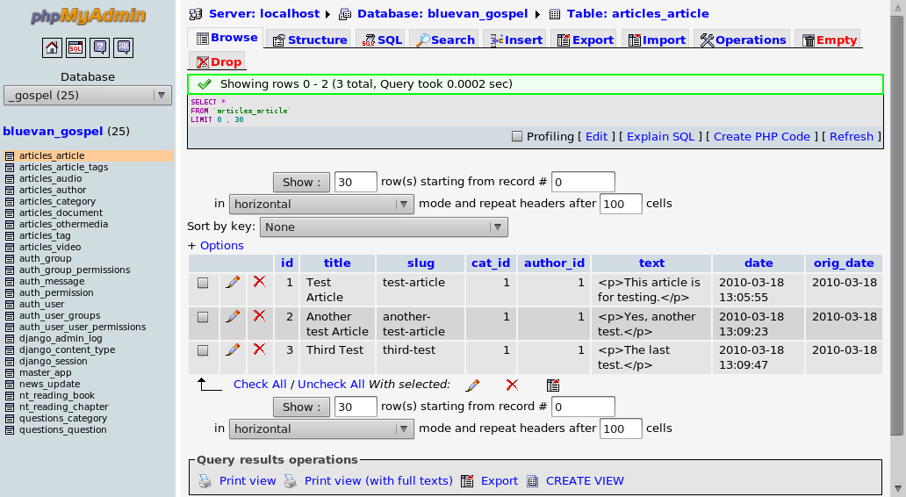Article Database View
See Appendex A for code excerpts for this use case. Due to the nature of the Django framework, the models.py file serves as the database schema.

Initial Menu Hierarchy
- Articles
  - Categories
  - Tags
  - Authors
- Questions and Answers
  - Ask a Question
- Users
- Book Store
  - Products
  - Cart
- Login

- My Profile
  - Update User Profile
  - Delete User
- Administration
  - Articles
    - Add Article
    - Update Article
    - Delete Article
  - Authors
    - Add Author
    - Update Author
    - Delete Author
  - Categories
    - Create Category
    - Update Category
    - Delete Category
  - Users
    - Unapproved Users
    - Delete User
  - Questions
    - Update Question
    - Delete Question
  - Products
    - Add Product
    - Update Product
    - Delete Product
  - Orders
    - Unshipped Orders
    - Adjust Order
    - Recent Orders

Report Samples

Article Report by Category

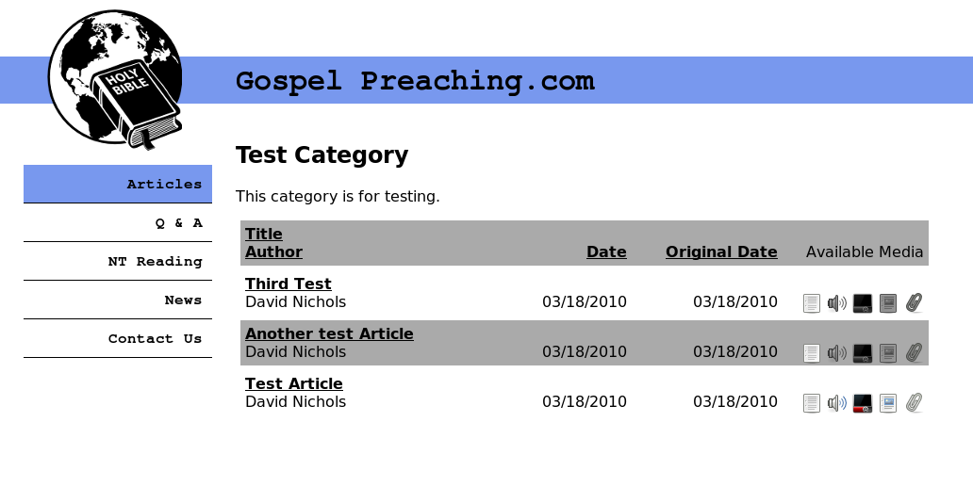
Article Report by Author
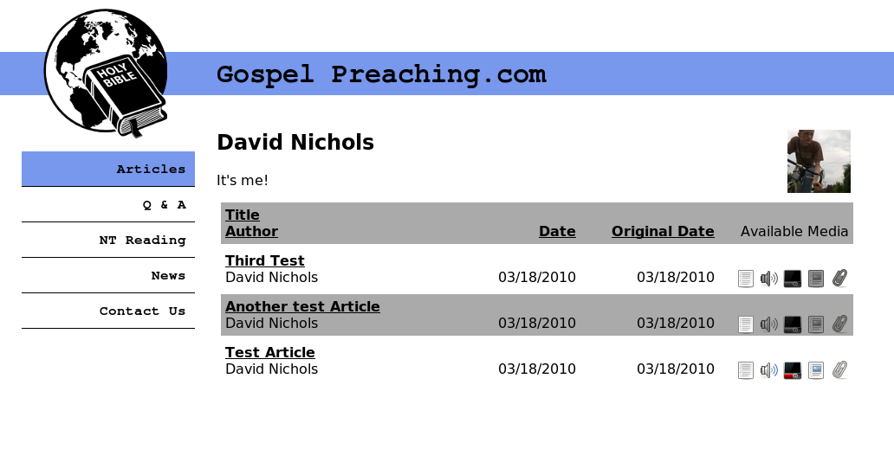

Project Monitoring/Reporting To Date
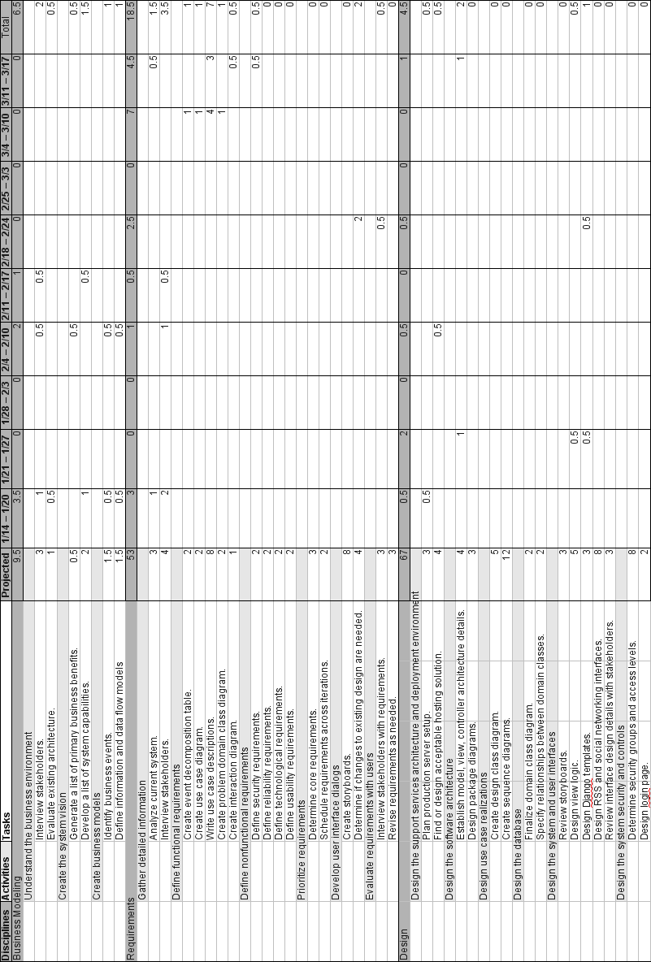
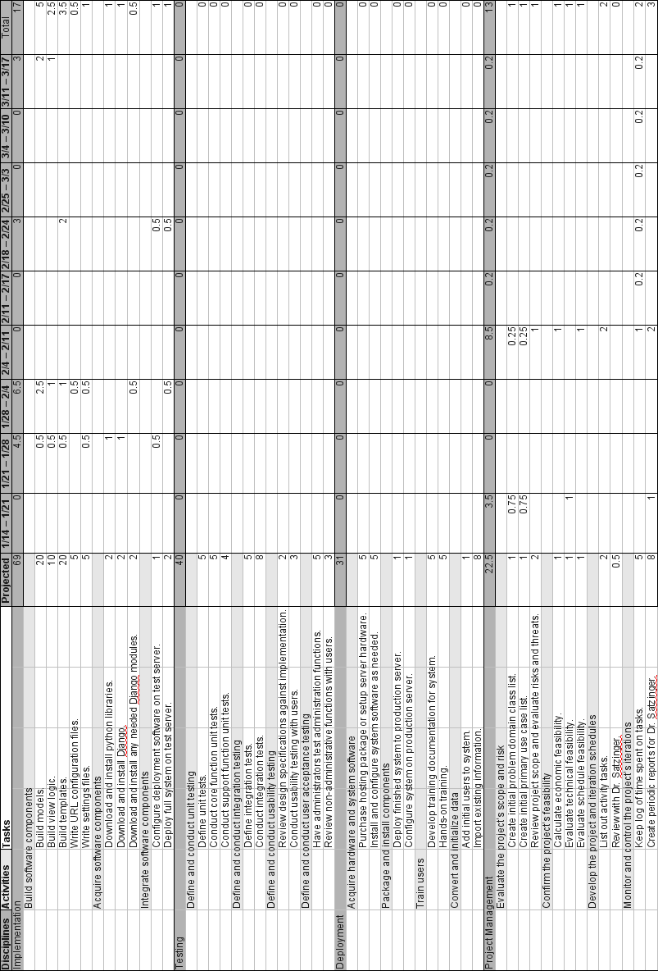
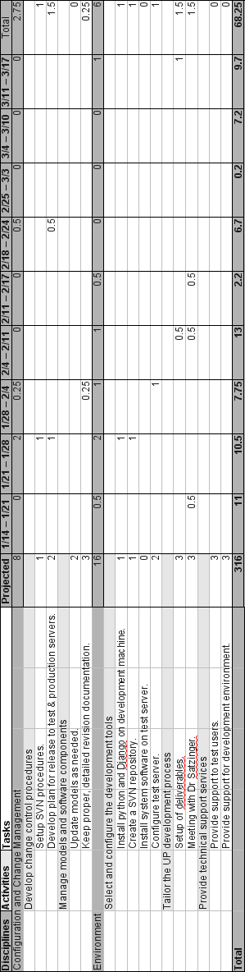

Appendix A: Code Excerpts

models.py
from django.db import models
from datetime import date
from tinymce import models as tinymce_models
import os.path
from django.conf import settings

def get_filename(instance, filename):
split = filename.split('.')
ext = ''.join(['.', split[len(split) - 1]])
month = ''.join([str(date.today().year), '_', str(date.today().month)])
slug = instance.parent.slug
t = (None,"audio")[isinstance(instance, Audio)]
t = (t,"video")[isinstance(instance, Video)]
t = (t,"docs")[isinstance(instance, Document)]
t = (t,"other")[isinstance(instance, OtherMedia)]
fn = ''.join(['article/', month, '/', t, '/', slug, ext])
i = 1
if instance.src:
instance.src.delete()
while True:
if os.path.exists(''.join([settings.MEDIA_ROOT, fn])):
fn = ''.join(['article/', month, '/', t, '/', slug, '_', str(i), ext])
else:
return fn

def convert_youtube(url):
sep = url.find('?v=')
if sep > 0:
url = 'http://www.youtube.com/v/%s' % url[sep + 3:]
sep = url.find('&')
if sep > 0:
url = url[:sep]
return url

class Category(models.Model):
name = models.CharField(max_length=200)
slug = models.SlugField()
description = tinymce_models.HTMLField(blank=True)
class Meta:
verbose_name_plural = "categories"
ordering = ['name']
def __unicode__(self):
return self.slug

class Author(models.Model):
name = models.CharField(max_length=200)
slug = models.SlugField()
bio = tinymce_models.HTMLField(blank=True)
photo = models.FileField(upload_to=get_filename, null=True, blank=True)
class Meta:
verbose_name_plural = "authors"
ordering = ['name']
def __unicode__(self):
return self.name

class Tag(models.Model):
name = models.CharField(max_length=200)
slug = models.SlugField()
class Meta:
verbose_name_plural = "tags"
ordering = ['name']
def __unicode__(self):
return self.name

class Article(models.Model):
title = models.CharField(max_length=200)
slug = models.SlugField()
cat = models.ForeignKey('Category')
author = models.ForeignKey('Author')
tags = models.ManyToManyField(Tag, related_name='articles')
text = tinymce_models.HTMLField(blank=True)
date = models.DateTimeField('date published', auto_now_add=True)
orig_date = models.DateField('date originally created')
class Meta:
ordering = ['-date']
def __unicode__(self):
return self.slug

class Audio(models.Model):
parent = models.ForeignKey('Article')
title = models.CharField(max_length=200)
src = models.FileField(upload_to=get_filename, null=True, blank=True)
class Meta:
verbose_name_plural = "audio"
ordering = ['parent','title']
def __unicode__(self):
return ''.join([self.parent.slug, "/", self.title])

class Video(models.Model):
parent = models.ForeignKey('Article')
title = models.CharField(max_length=200)
src = models.FileField(upload_to=get_filename, null=True, blank=True)
url = models.URLField(null=True, blank=True)
class Meta:
ordering = ['parent','title']
def save(self):
self.url = convert_youtube(self.url)
super(Video, self).save()
def __unicode__(self):
return ''.join([self.parent.slug, "/", self.title])

class Document(models.Model):
parent = models.ForeignKey('Article')
title = models.CharField(max_length=200)
src = models.FileField(upload_to=get_filename, null=True, blank=True)
class Meta:
ordering = ['parent','title']
def __unicode__(self):
return ''.join([self.parent.slug, "/", self.title])

class OtherMedia(models.Model):
parent = models.ForeignKey('Article')
title = models.CharField(max_length=200)
src = models.FileField(upload_to=get_filename, null=True, blank=True)
class Meta:
verbose_name_plural = "other media"
ordering = ['parent','title']
def __unicode__(self):
return ''.join([self.parent.slug, "/", self.title])

views.py
from django.shortcuts import render_to_response, get_object_or_404
from gospel_preaching.articles.models import Article, Category
from django.template import RequestContext
from django.core.paginator import Paginator
from django.conf import settings

def index(request):
order = request.GET.get('order', '-date')
page = request.GET.get('page', 1)
try:
perpage = settings.ARTICLES_PER_PAGE
except AttributeError:
perpage = 10
pager = Paginator(Article.objects.all().order_by(order), perpage)
return render_to_response('articles/index.html', {'all_articles': pager.page(page).object_list, 'order': order, 'page': pager.page(page), 'pager': pager}, context_instance = RequestContext(request))

def detail(request, cat, slug):
a = get_object_or_404(Article, slug__exact=slug)
return render_to_response('articles/detail.html', {'article': a}, context_instance = RequestContext(request))

def cat(request, cat):
order = request.GET.get('order', '-date')
page = request.GET.get('page', 1)
try:
perpage = settings.ARTICLES_PER_PAGE
except AttributeError:
perpage = 10
c = get_object_or_404(Category, slug__exact=cat)
pager = Paginator(c.article_set.all().order_by(order), perpage)
return render_to_response('articles/cat.html', {'cat': c, 'articles': pager.page(page).object_list, 'order': order, 'page': pager.page(page), 'pager': pager}, context_instance = RequestContext(request))

urls.py
from django.conf.urls.defaults import *

# Uncomment the next two lines to enable the admin:
# from django.contrib import admin
# admin.autodiscover()

urlpatterns = patterns('',
# Example:
# (r'^gospel_preaching/', include('gospel_preaching.foo.urls')),

# Uncomment the admin/doc line below and add 'django.contrib.admindocs'
# to INSTALLED_APPS to enable admin documentation:
# (r'^admin/doc/', include('django.contrib.admindocs.urls')),

# Uncomment the next line to enable the admin:
# (r'^admin/(.*)', admin.site.root),
(r'^$', 'gospel_preaching.articles.views.index'),
(r'^(?P<cat>[a-zA-Z0-9_-]+)/$', 'gospel_preaching.articles.views.cat'),
(r'^(?P<cat>[a-zA-Z0-9_-]+)/(?P<slug>[a-zA-Z0-9_-]+)/$', 'gospel_preaching.articles.views.detail'),
)

admin.py
from gospel_preaching.articles.models import Article, Audio, Video, Document, OtherMedia, Category, Author, Tag
from django.contrib import admin

class AudioInline(admin.TabularInline):
model = Audio
extra = 1

class VideoInline(admin.TabularInline):
model = Video
extra = 1

class DocInline(admin.TabularInline):
model = Document
extra = 1

class OtherInline(admin.TabularInline):
model = OtherMedia
extra = 1

class ArticleAdmin(admin.ModelAdmin):
prepopulated_fields = {"slug": ("title",)}
search_fields = ['title', 'text']
date_hierarchy = 'date'
list_display = ('title', 'author', 'cat', 'date', 'orig_date')
inlines = [AudioInline, VideoInline, DocInline, OtherInline]

class CategoryAdmin(admin.ModelAdmin):
prepopulated_fields = {"slug": ("name",)}

admin.site.register(Article, ArticleAdmin)
admin.site.register(Audio)
admin.site.register(Video)
admin.site.register(Document)
admin.site.register(OtherMedia)
admin.site.register(Category, CategoryAdmin)
admin.site.register(Author)
admin.site.register(Tag)

index.html
{% extends "base.html" %}
{% load custom %}

{% block css %}
{% endblock %}
{% block script %}
{% endblock %}

{% block main %}
<h2>{{ cur_app.header }}</h2>
{{ cur_app.description|safe }}
{% if all_articles %}
<div class="list_table">
<div class="list_item_odd">
<span class="list_title"><a href="{% orderurl 'title' order %}">Title</a></span>
<span class="list_cat"><a href="{% orderurl 'cat__title' order %}">Category</a></span><br />
<span class="list_author"><a href="{% orderurl 'author' order %}">Author</a></span>
<span class="list_dates_media">
<span class="list_date"><a href="{% orderurl 'date' order %}">Date</a></span>
<span class="list_orig_date"><a href="{% orderurl 'orig_date' order %}">Original Date</a></span>
<span class="list_media">Available Media</span>
</span>
</div>
{% include "helpers/navigation.html" %}
{% for article in all_articles %}
<div class="list_item_{% cycle 'even' 'odd' %}">
<span class="list_title"><a href="{% url gospel_preaching.articles.views.detail article.cat.slug article.slug %}">{{ article.title }}</a></span>
<span class="list_cat"><a href="{% url gospel_preaching.articles.views.cat article.cat.slug %}">{{ article.cat.title }}</a></span><br />
<span class="list_author">{{ article.author }}</span>
<span class="list_dates_media">
<span class="list_date">{{ article.date|date:"m/d/Y" }}</span>
<span class="list_orig_date">{{ article.orig_date|date:"m/d/Y" }}</span>
<span class="list_media">
<img src="{{ MEDIA_URL }}img/text_{{ article.text|striptags|yesno }}.png" />
<img src="{{ MEDIA_URL }}img/audio_{{ article.audio_set.all|yesno }}.png" />
<img src="{{ MEDIA_URL }}img/youtube_{{ article.video_set.all|yesno }}.png" />
<img src="{{ MEDIA_URL }}img/doc_{{ article.document_set.all|yesno }}.png" />
<img src="{{ MEDIA_URL }}img/other_{{ article.othermedia_set.all|yesno }}.png" />
</span>
</span>
</div>
{% endfor %}
{% include "helpers/navigation.html" %}
</div>
{% else %}
<p>No articles are available.</p>
{% endif %}
{% endblock %}

detail.html
{% extends "base.html" %}

{% block css %}
<link rel="stylesheet" href="{{ MEDIA_URL }}style/video.css" type="text/css" />
{% endblock %}
{% block script %}
<script type="text/javascript" src="{{ MEDIA_URL }}scripts/audio-player.js"></script>
<script type="text/javascript" src="{{ MEDIA_URL }}scripts/flowplayer-3.1.0.min.js"></script>
<script type="text/javascript" src="{{ MEDIA_URL }}scripts/flowplayer.controls-3.0.2.js"></script>
{% endblock %}

{% block main %}
<h2>{{ article.title }}</h2>
<table class="header_block">
<tr><td>Catagory:</td><td><a href="{% url gospel_preaching.articles.views.cat article.cat.slug %}">{{ article.cat.title }}</a></td></tr>
<tr><td>Date Uploaded:</td><td>{{ article.date|date:"m/d/y" }}</td></tr>
<tr><td>Original Date:</td><td>{{ article.orig_date|date:"m/d/y" }}</td></tr>
<tr><td>Author:</td><td>{{ article.author.name }}</td></tr>
</table>
{{ article.text|safe }}
{% if article.audio_set.all %}
<div class="content_block">
<h3>Audio</h3>
{% for audio in article.audio_set.all %}
<h5>{{ audio.title }}</h5>
<object id="{{ article.slug }}" height="24" width="290" data="{{ MEDIA_URL }}scripts/player.swf" type="application/x-shockwave-flash">
<param value="{{ MEDIA_URL }}scripts/player.swf" name="movie"/>
<param value="playerID={{ article.slug }}&soundFile={{ MEDIA_URL }}{{ audio.src }}" name="FlashVars"/>
<param value="high" name="quality"/>
<param value="false" name="menu"/>
<param value="transparent" name="wmode"/>
</object><br />
<a href="{{ MEDIA_URL }}{{ audio.src }}">Download</a>
{% endfor %}
</div>
{% endif %}
{% if article.video_set.all %}
<div class="content_block">
<h3>Video</h3>
{% if article.video_set.all %}
{% for video in article.video_set.all %}
<h5>{{ video.title }}</h5>
{% if video.url %}
<object width="425" height="344" style="display:block;">
<param name="movie" value="{{ youtube.url }}&hl=en&fs=1&rel=0"></param>
<param name="allowFullScreen" value="true"></param>
<param name="allowscriptaccess" value="always"></param>
<embed src="{{ youtube.url }}&hl=en&fs=1&rel=0" type="application/x-shockwave-flash" allowscriptaccess="always" allowfullscreen="true" width="425" height="344"></embed>
</object>
{% endif %}
{% if video.src %}
<a
href="{{ MEDIA_URL }}{{ video.src }}"
style="display:block;width:425px;height:344px"
id="player{{ video.id }}">
</a>
<!--HTML based control bar: <div id="controls{{ video.id }}" class="video_controls"></div>-->
<script>
<!--
flowplayer("player{{ video.id }}", "{{ MEDIA_URL }}scripts/flowplayer-3.1.0.swf", {
clip: {
autoPlay: false,
autoBuffering: true
},

plugins: {
controls: {
url: '{{ MEDIA_URL }}scripts/flowplayer.controls-3.1.0.swf',
backgroundColor: '#000000',
backgroundGradient: '[0.2, 1.0, 0.6]',
buttonColor: '#707070',
sliderColor: '#707070',
bufferColor: '#A0A0A0',
progressColor: '#FF0000',
buttonOverColor: '#A0A0A0',
volumeSliderColor: '#707070',
timeBgColor: '#707070',
timeColor: '#FF1010',
tooltipColor: '#707070'
}
}

});
//-->
</script>
<a href="{{ MEDIA_URL }}{{ video.src }}">Download</a>
{% endif %}
{% endfor %}
{% endif %}
</div>
{% endif %}
{% if article.document_set.all %}
<div class="content_block">
<h3>Document</h3>
{% for doc in article.document_set.all %}
<h5>{{ doc.title }}</h5>
<a href="{{ MEDIA_URL }}{{ doc.src }}">Download</a>
{% endfor %}
</div>
{% endif %}
{% if article.othermedia_set.all %}
<div class="content_block">
<h3>Other Media</h3>
{% for media in article.othermedia_set.all %}
<h5>{{ media.title }}</h5>
<a href="{{ MEDIA_URL }}{{ media.src }}">Download</a>
{% endfor %}
</div>
{% endif %}
{% endblock %}

Legal Notes

This work by David Nichols is licensed under a Creative Commons Attribution-Noncommercial-Share Alike 3.0 United States License. To view a copy of this license, visit <http://creativecommons.org/licenses/by-nc-sa/3.0/us/>. Some rights reserved.

GospelPreaching.com and the associated globe logo are Copyright © 2009 by Contending for the Faith Publications. All rights reserved.



The code included herein is Copyright © 2010 by David Nichols.

The code files included in this documentation are part of GospelPreaching.com.

GospelPreaching.com is free software: you can redistribute it and/or modify it under the terms of the GNU General Public License as published by the Free Software Foundation, either version 3 of the License, or (at your option) any later version.

GospelPreaching.com is distributed in the hope that it will be useful, but WITHOUT ANY WARRANTY; without even the implied warranty of MERCHANTABILITY or FITNESS FOR A PARTICULAR PURPOSE. See the GNU General Public License for more details.

Please see <http://www.gnu.org/licenses/gpl.html> for a copy of the GNU General Public License.

Other Notes
I want to give credit to the amazing Django web framework and thank the amazing people that work on it. “It lets you build high-performing, elegant Web applications quickly.” Please check out the Django project's site: <http://www.djangoproject.com/>


